Dear Students,
A hearty welcome to our Life Drawing class, which starts Monday July 14, 2008 and ends Wednesday August, 20, you will continually see references to due dates as "Day 1," "Day 2," etc. For our purposes, Day 1 is Monday, Day 2 is Tuesday, etc.
The human body is one of the most complex and beautiful forms to render and a working knowledge and mastery in this area is transferable into all areas of drawing. Planes, light, volume and form are the basics of drawing and the culmination of the human figure. Being well versed in this area will give you mastery in drawing anything as all forms can be broken down into basic shapes that can be seen in the human figure.
This course is designed to exploit this knowledge and empower you with life long skills in drawing. By completion of this course the student will be able to understand and skillfully apply anatomical and proportional relationships in drawings of the human form from working with live models. This will be based on an understanding of planes, contours and mass of the human structure and how light affects this form adding depth and dimension as you create the illusion of three dimensions in two-dimensional space.
I expect your best; we expect great things from you!
Please read through all materials and the “Student Guidelines” file that is located in the “Please Read and Respond” area of your home page. Important information concerning the success of the course is found there.
Please read through all materials and the “Please Read and Respond and Expectations areas” file located at your home page. Important information concerning the success of the course is found there with reference to disability information, plagiarism, Turnitin.com and Smarthinking.com.
A few pointers that are important; it is required to be in class four out of the seven days a week or the grade is negatively affected.
I do not excuse late assignments, unless there are sever extenuating circumstances, and I am notified quickly. Assignments that are submitted late will receive grade reduction for every day late. Remember that our online learning environment runs at a quick pace. Please feel free to contact me when you need help by email or phone. I am very reachable; my number is 518-618-0502 or 518-961-3392. I have your highest success at interest and I will do everything possible to see that to fruition.
Please, log in to the classroom ASAP as you have an assignment due Day 2 of our first week.
Again a Warm and Hearty Welcome to you All! I look forward to your creative contributions!
Most Respectfully,
Nancy
Following are the required materials, books and software necessary for the successful completion of this course.
Information for Summer 2007 Quarter
Text Book Requirements:
Title:
Atlas of Human Anatomy for the Artist
Author:
Peck
Edition / Copyright:
1st, March 82
Publisher:
Oxford UP
ISBN:
0195030958
Title:
Basic Figure Drawing Techniques (North Light Basic Painting),
Author:
Albert
Edition / Copyright:
/1994
Publisher:
F&W Publications
ISBN:
0891345515
Title:
Virtual Pose 3: The Ultimate Visual Reference Series for Drawing the Human Figure, with CD
Author:
Chakkour
Edition / Copyright:
March 2004
Publisher:
F & W Publishing
ISBN:
0971401047
Technological Requirements:
Computer:
PC: As a general guideline students should not have computer specifications less than a Pentium III CPU, Windows 2000 or XP, and 512 MB RAM.
MAC: As a general guideline students should not have computer specifications less than a MAC G4 processor, MAC OS X, and 512 MB RAM.
Software:
Microsoft Office Professional (including Word, Excel, Powerpoint, Access and Outlook), Norton Antivirus, Adobe Acrobat Professional 3
Peripherals:
Printer, Scanner, Digital Camera 3
Browser:
Courses offered online are best viewed using Microsoft Internet Explorer v5.5/6.0 (PC), Safari 1.0 (MAC), or Firefox.
Attention Mac Users: While you can use Safari 2.0 to view classes, some animation pieces may not be available with Safari 2.0 and we highly recommend using Firefox or Internet Explorer to view your class material using a Mac computer.
Material Requirements:
Pen/pencil, idea journal and paper, scanner, back-up storage device, printer, Newsprint pad (18" x 24"), Sketch paper (11" x 14" and 18" x 24" pads), 2-4 Sheets drawing paper 22” x 30” (ex: Stonehenge, Rives BFK, Strathmore), 2B, 6B, 9B graphite pencils, Graphite stick (6-9B), Vine charcoal sticks (medium and soft), Charcoal pencils (hard, soft),"Charkole" sticks, Rust, white, and brown conté crayons, Mars white plastic eraser, Kneaded eraser, Blending sticks (small, large), Sharpener (electric or hand), Drawing board (surface on which to draw), and aluminum clips.

G120 Readings & Assignments: Week 1
Week 1 Readings
Complete the following readings early in the week:
- Read the Week 1 Online Lectures.
- Read chapter 1, pages 2-8 and Chapter 3, pages 22-47 from the textbook, Basic Figure Drawing Techniques by Greg Albert.
- Read chapter 4, pages 48-69 from the textbook, Basic Figure Drawing Techniques by Greg Albert.
Week 1 Assignments Overview
Assignment Summary: Week 1 | Due Date
Assignment 1: Introduction/Autobiography | Tuesday, July 15, 2008
Assignment 2: Proportion, Rhythm, Measuring and Balancing the Human Figure | Tuesday, July 15, 2008
Assignment 3: The 4-Part Figure and Gesture Drawing I | Thursday, July 17, 2008
Assignment 4: Upper Limb—Anatomy Drawing | Saturday, July 19, 2008
Remember that all Assignment details can be found on the assignment pages located throughout the week. Go to those specific pages for direction on how to complete each individual assignment.

Week 1 Overview
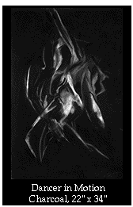
Learning to draw the human figure is a centuries-old tradition for developing artists. Used either as a foundation vehicle to increase technical and creative skill, or as the primary subject matter in the completed artwork, figurative art is both steeped in history as well as employed as a modern art form.
Consider the work of contemporary figurative artist, Robin Masi. Like so many artists before, rigorous training and producing countless life drawings is required in order to accurately render the human form.
Drawing the figure accurately and successfully comes from seeing the figure from several perspectives: drawing from a live model, self portraiture, anatomical renderings, drawing from Old Masters and expert life drawings, creating many quick-poses (gesture), and long-pose (rendered) drawings. This class will employ all these perspectives to help the student see the figure and draw it in the most comprehensive and varied way possible.
Learning Outcomes:
Apply anatomical and proportional relationships to the structural sketches of the live model.

Resources

Art Supplies:
- Newsprint pad (18" x 24")
- Sketch paper (11" x 14" and 18" x 24" pads)
- 2B, 6B, 9B graphite pencils
- Graphite stick (6-9B)
- Vine charcoal sticks (medium and soft)
- Charcoal pencils (hard, soft)
- "Charkole" sticks
- Rust, white, and brown conté crayons
- Mars white plastic eraser
- Kneaded eraser
- Blending sticks (small, large)
- Sharpener (electric or hand)
- Drawing board (surface on which to draw)
- Aluminum clips
You should be able to get these supplies from most good art supply stores. Try to avoid the "craft-oriented" or large "office-supply" shops, as their products are usually inferior and more expensive. If you are serious about being an artist you must be selective and knowledgeable about what tools work best for you and have access to the best selection possible.

Online Resources:
Pearl Art and Craft ( www.pearlpaint.com)

Technology Needed:
Scanner (to send images to instructor for review)
Access to a Digital Camera (to photograph and send larger works)
Workstation with Internet Access (Pentium or Macintosh computer)

Access to Live Models:
Access to live models is essential for this course. In order to accurately represent the figure the beginning student MUST draw frequently from the live human form. Flattened representations (drawings, photographs, and VRML movies) will be used in conjunction with your self-portraits but are not meant as your primary drawing references.

Assignment and Discussion Question Deadlines
On the first day of each week you are responsible for going through the notes to determine the assignments and discussion questions for the week. Plan your week accordingly and as specified by the due dates. Late assignments will be graded down.

Submitting Assignments
As a prerequisite to this course you must have access to either a digital camera and/or a scanner in order to post digitized images of your assignments in the discussion areas. Post JPEG files in the appropriate discussion area for each assignment. Be sure your image is reduced to be no larger than a 600K file. If you need additional help in this area you can ask your instructor, visit the online Library for more information, and, also, sign up to take a scheduled online Training Session in Basic Photoshop.

Model and Life Drawing Session Setup

The Artist's Life Drawing Setup
A successful life-modeling drawing session encompasses several important elements: the model's setting, accurate timing, lighting, and where you sit/stand in order to draw.

Easel and Materials
If you were in a classroom, you would be set-up at an easel with a drawing board holding your drawing pad. Your materials would be on your easel or on a table next to you, easy to access. At home or in your studio, take some time to set yourself up in a large space with some type of vertical method to hold your paper (an easel, propped against a chair or table, etc.). An easel can be purchased for $20-$30.

Vertical axis
If you sit in a chair and hold your paper/board flat, you are already distorting your drawing view. Therefore, a vertical or slanted surface is essential.

Seated vs. Standing
Ideally, you should stand the entire session, sitting only for detailed work. It is important for the artist to be as loose as possible in order to draw. Using your entire arm/wrist is essential. The best drawings are from an energetic and enlivened artist, not one seated for hours holding a pencil tightly as if working out math calculations.

Elevation
In a classroom setting, the model would be elevated at least 2-3 feet on a stand in order for his/her midsection to be as close to your eye level as possible. Looking down or up at a figure provides an interesting perspective to draw. However, it is more difficult than a straight on perspective. It is best to elevate your model on crates, chairs, or boards. If not, the floor is fine.

Space/Setting
To give the model freedom to move, have your modeling session in as large a space as possible. You should also have comfortable cushions, a stool, and a chair available for some positions and a rug/mat available for reclining poses.

Timing
You will be responsible for accurately following a timed drawing pattern. Give your model a watch or clock with a secondhand in order for him/her to pose for 1-5 minutes and 5-15 minute sessions.

Lighting
It is extremely important to place a single source of light on the model. One light source (preferably high and slightly to the front and side) gives the best light for creating depth and form. Use a floor lamp with at least a 75-100 Watt bulb. You do not want harsh black/white contrasts, but muted shadows that are easily defined.

Self-Portrait Sessions

Mirror
You should have access to a full-size mirror in order to draw your entire form at once.

Attire
A willingness to draw from your own nude form is optimal to your progression as an artist; however, minimally clothed is acceptable.

Drawing the Human Figure

Introduction
When students draw a figure, they only see the outline of the form, usually starting from the head or shoulder, and slowly working down without knowing where the end point is. This "paper-doll-cut-out" approach often leads to figure drawings that look out of proportion, off-balance, and anatomically disfigured.
When drawing the human form, an understanding of anatomy and the correct proportions of the body are a must. It is essential to train the eye to see what is going on inside the body before depicting the outline. The more students learn about balance, proportion and anatomy, the more they will see and eventually be able to translate that information into their drawings.

Proportion
Proportions are critical in drawing the human figure. If one can depict correct proportions of the body, then one is a long way down the road to producing a strong representation. There are many approaches to drawing the human body, but nearly all start with getting the proportions down correctly.
There are 4 types of cannons for the proportions of the human body, and all are based on the size of the human head in relation to the body.
- Standard: 7 - 7 ½ heads
- Classic: 8 heads
- Heroic: 8 ½ - 9+ heads
- Fashion: 9 ½ - 10+ heads

Standard
The common human body is usually between 6 and 7 heads tall. As you draw your model, use a pencil or your eraser to measure the size of the head. Then, using the head size as a ruler, measure the rest of the body and count how many heads high they are, how many heads across the shoulders, and so on.
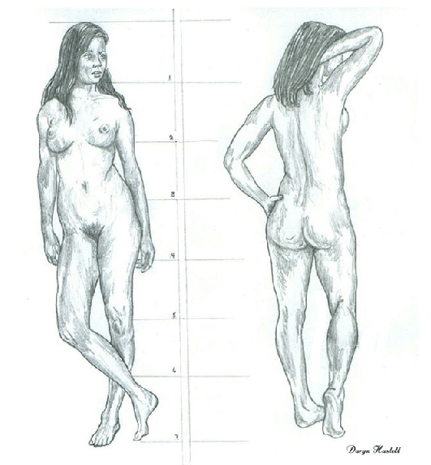
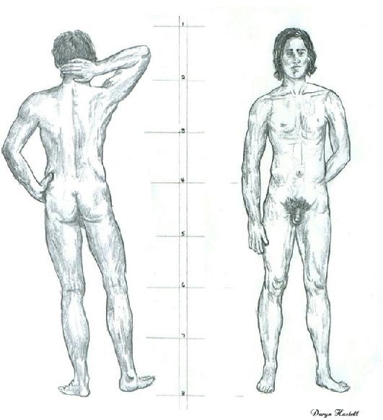

Heroic
The heroic figure can be anywhere from 8 ½ to 10 heads tall. The figure proportions exaggerate the shoulders and chest. This format is used to describe idealized and exaggerated legendary figures.
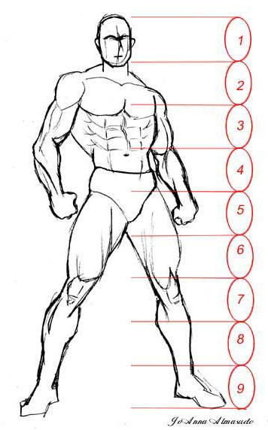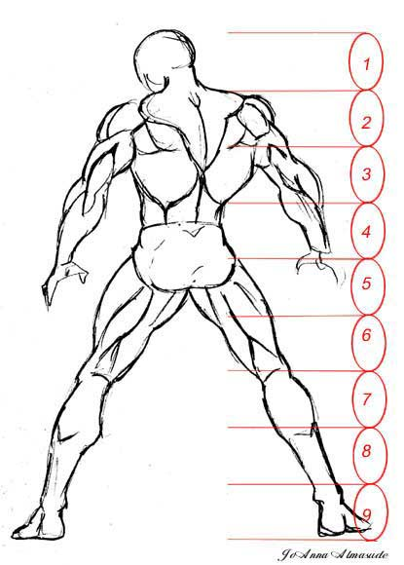

Fashion
In Fashion Illustration, the goal of the figure is to show the clothes in the most attractive manner. Elongating the legs sometimes by 2 heads is a primary strategy!
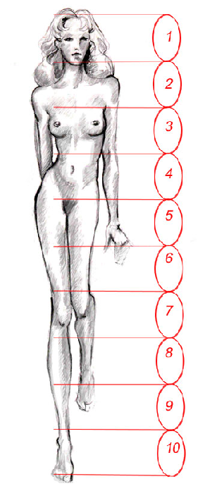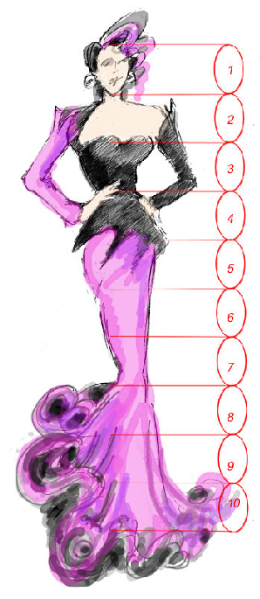

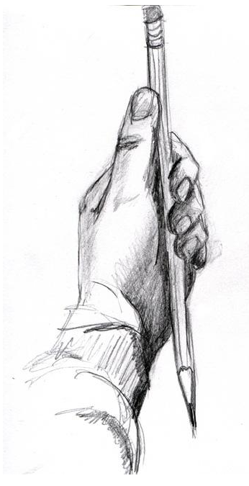
Rhythm
As in poetry, music, and nature, art has its own rhythm or harmony, which is conveyed in outline, color, light, and shade. The body is an amazing machine that has its own lyricism and sense of harmony.

Measuring
When drawing the figure, use the time-honored method of measuring to compare your subject's proportions to your drawing. Hold your arm out straight (bending your arm will cause distortion) and use your thumb on the pencil to measure certain parts of the figure in relation to one another. For example, if your model's torso is 1 1/2 of her heads high, your drawing's measurements should be the same, regardless of its size.

Balance
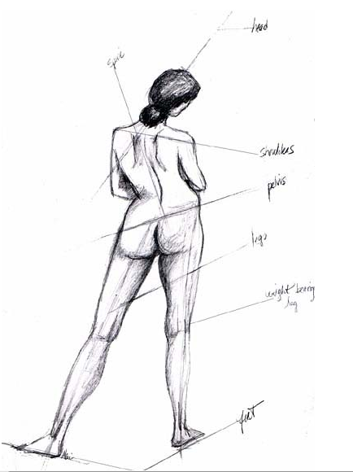
In a figure drawing, there must be a sense of security or balance, in order to ensure that the figure does not appear to be leaning awkwardly or falling over. When analyzing the figure, the first step is to identify the primary area. That is your center of balance, or point of gravity. When you find that point make a mark on your paper to insure your figure is centered on that important area.
In standing poses, the center of balance is usually equally balanced between each foot or shifted to one foot or the other. It is important to determine where this center of gravity is, since this is how the body supports itself. In addition, check the relation of the head to the center of gravity or point of balance - oftentimes the head is right over the gravity point, which is how the figure is able to stand upright.
In seated and reclining poses, the center of gravity is distributed between one or more body parts. Sometimes, it is between the hand and the buttocks. In reclining poses, the weight is distributed evenly from head or elbow, to trunk, buttocks, legs, and feet.

The 4-Part Figure and Gesture Drawing
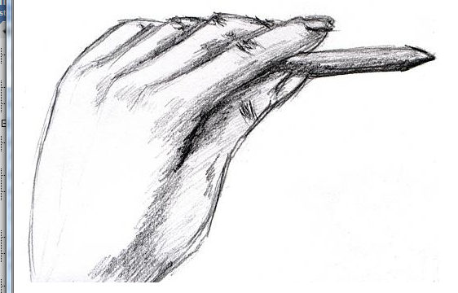
As stated above, in order to get to an accurately and dynamically rendered life drawing, one must go through the process of learning to see what is going on inside the body. That is achieved by creating a "gesture" drawing of the figure before rendering. A gesture drawing is a quick drawing depicting the "essential components" of the figure: the proportion, balance, rhythm, and references to its anatomical elements.

Before You Begin
Before undertaking this process, it is important for you to be as open, loose, and energetic as possible. Going through these four steps will help you create dynamic, rhythmic, and exciting figure drawings. In contrast, a tight and controlled approach will be antithetical to the entire process. Stretch, loosen your wrists, neck, etc. and get ready to begin. You may even put on some favorite music to add to the process.

The Artist's Hold
In order to keep yourself as loose as possible, practice holding your drawing tool between your thumb and forefinger. Do not hold it as you would hold a pen or pencil in order to write. The reason is that your range of motion when holding a pencil as if to write is only about 1-2 inches - this will create stiff, rigid, and awkward drawings. Holding your tool loosely will get your wrist and entire arm involved in the process.

There are four steps to help you create a successful figure drawing. The first two are covered in this lesson. Steps three and four are covered on the next page.

Step 1 - The Stick Figure
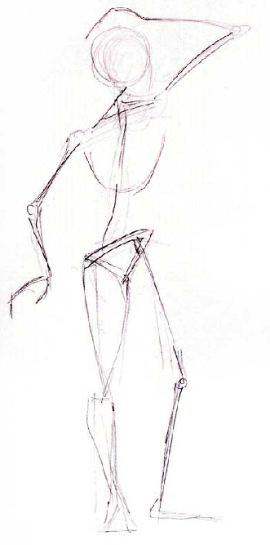
The skeletal structure of the body is most important foundation of the life drawing process. If you do not have the "stick figure" or skeletal structure of your figure accurate, there is a good chance your drawing will be awkward or "off." Spending time training your eye to create a stick figure for every drawing you make will greatly enhance your ability.
The stick figure describes the center and balance points of the figure. To begin, we will use standing poses. The key areas are:
- Direction of the head - drawn as an oval.
- Horizontal direction of the shoulders (straight across or angled).
- Horizontal direction of the hips (straight across or angled).
- Gravity point/weight-bearing leg.
- Non-weight bearing leg.
- Direction of the feet - straight line.
- S-curve of the spine.
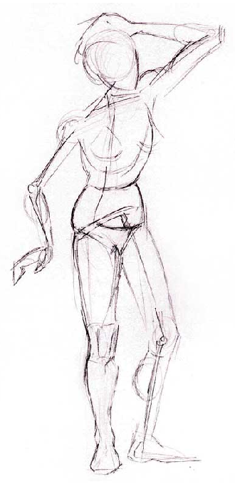
- Direction of the arms.

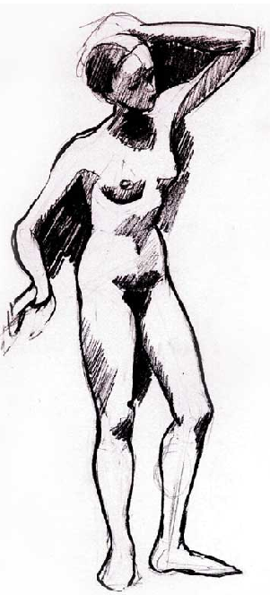
Step 3 - Softened Geometric Shapes, Big Lights/Big Darks
You are now ready to soften the edges of the geometric shapes based on the pose and the model's form. Change the shapes and outlines to be closer to the human body. This is also the time to delineate the big dark and big light areas of the body. You can also add the hair and rough features of the face, hands, and feet.

Step 2 - Geometric Shapes
In beginning drawing, you learned how to break any composition into its most essential geometric shapes (circle, square, rectangle, cone, oval, etc.) to create structure and mass. The same principle applies to this next step in describing each part of the body. The key geometric shapes of the body are:
- Head - oval.
- Ribcage/torso - a large irregular cylinder or oval.
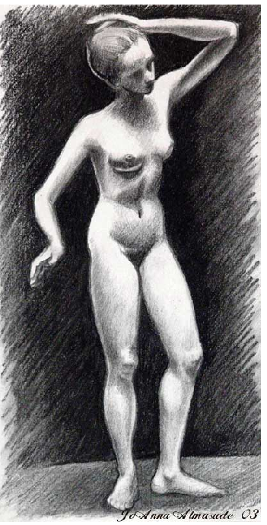
- Pelvis - a short irregular cylinder.
- Arms/legs - long irregular cylinders or long ovals.
- Hands/feet - irregular triangles.
- Knees/elbows - small circle.

Step 4 - Anatomical Contours, Details of Face/Hands/Feet, Softened Lights/Darks
This is the final step of your drawing. You can now "render" your drawing for the anatomical contours and features unique to your model. You can also now use a full range of value/tone to bring as much three-dimensionality as possible. Remember the greater the value range, the more dimensionality that will appear

When to Stop
If your drawing has accurately gone through the first three steps, the drawing will be successful. However, it is also easy to "kill" a drawing at this stage and lose much of the early freshness of the earlier stages. This is because you might stiffen up and go to a more rigid approach when it's time for the details. It is important to keep yourself as loose as you were in the earlier stages, yet maintain control. It is also important to know when to stop.

Timing
An experienced figure artist can go through steps 1-3 in as little time as 30 seconds-2 minutes. That is a completed "gesture" drawing which has all the essential components of the figure ready for rendering. Your long-term goal is to train your hand/eye to speed up to see these elements quickly in order to go through these steps simultaneously. However, in the beginning, it is important to go through the process step-by-step. Therefore, take between 1-3 minutes for each step.

Repeating the 4-Step Method
Do not worry about how well you are depicting the anatomical contours and detailed features at this stage. These areas will be addressed later in the course. The most important part is for you to practice Steps 1-3 as often as you can. The more drawings you do using this method, the more automatic the process will become and better trained your hand/eye coordination will become. Try to draw using this method throughout the course from as many live models as you can. This four-step drawing is the foundation for all your figure drawings.
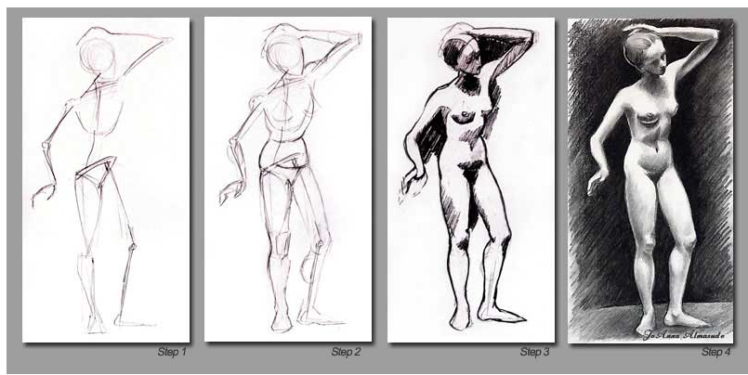

Upper Limb – Skeletal System
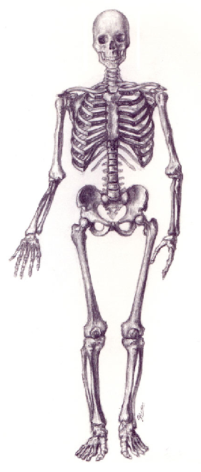
So far, you’ve learned the basics of drawing human figure. Now, let’s begin a more in-depth study of the anatomy. You will start by drawing the skeletal and muscular system of the upper limbs.

Introduction - The Skeletal System
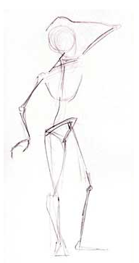
The skeleton is the structural framework of the body. Comprised of 206 bones, it is part support and part protector of the inner organs. Muscles move the majority of bones. The bones of the limbs are long and cylindrical but they are not straight. They have a slight S-curve, which adds to the body's grace as well as its structure. The ends of the bones are thicker than the centers because of how they meet at the joints. The bones of the male and female skeletons are almost the same. The only subtle differences are that male's bones tend to be slightly thicker and have longer limb bones. And, females tend to have a larger pelvis bone, especially relative to body size.
For the purposes of artistic anatomy, the landmark bones and muscles are presented. Landmark bones not only provide the basic structure of the body, but also are important to know in terms of their placement, as they show through the skin. They are depicted in a figure drawing via contour, light and shade, and should be accurately portrayed. They form the landscape of the body.

The Upper Limb/Arm
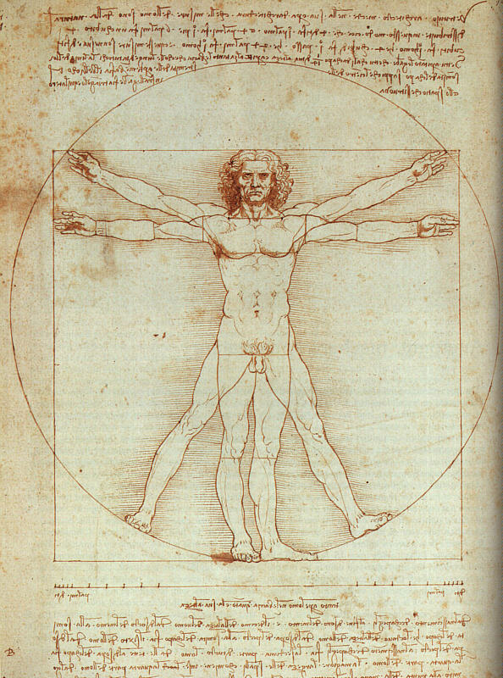
The arm can move freely in all directions and can rotate around its own axis. Its shape varies from one level to another. It is more spherical in the upper portion and has two sides in the lower (front and back). The length of the arms can be deceiving. When the arms are outstretched they equal the height of the figure from fingertip to fingertip. Study this famous image from Leonard da Vinci, which illustrates this point.
The tips of the shoulders, elbows, and wrists are always visible in the upper arms. The physical development and the amount of fat on the figure will determine how defined the contours and curves of the arm will be on the figure.

Bones of the Arm
Scapula - The scapula is a very important bone for the artist to understand. It has a complicated design, with many muscles attaching to it. The scapula can take on many different positions, depending on the rotation of the shoulder. Seen in the back view of the arm, it is attached as a slight curve to fit against the ribcage. It joins the ribcage at the top on the second rib and at the bottom on the seventh rib. The scapula has a triangular shape with a spine called the acromion process (shoulder blade). The spine can be felt easily as it is just under the skin.
In the movements of the scapula, look for the following three landmarks:
- The spine (acromion process), which will change angles depending on the movement of the shoulder joint
- The inferior angle (bottom), which will be moving under the latissimus dorsi. It is usually seen as the slightly curved edge of a triangle
- The border against the vertebrae, which will deepen depending on how far back the arm is swinging
Humerus - The humerus is a long and large bone of the upper arm.
Radius - The radius is one of the two bones in the forearm. The radius rotates in its joint with the ulna to change the position of the hand. It runs down the "thumb-side" of the arm.
Ulna - The ulna is one of the two bones in the forearm. It runs down the "little finger" side of the hand. It has the articular notch, which forms the elbow.

Joints of the Arm
- Shoulder - Where the humerus meets the scapula (back) and clavicle (front)
- Elbow - Where the humerus, ulna, and radius meet
- Wrist - The joint where the ulna meets the carpal bones of the hand

Observation
Look at yourself in the mirror. Move your arm in different directions, rotations, etc. Locate the joints and bones of your arm.
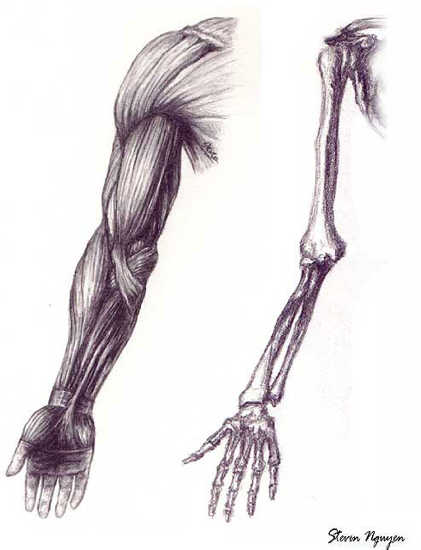

Introduction - The Muscular System
A muscle is a fibrous tissue that is used to move bones. Bones have several shapes and act as levers to move the body in different positions. There are two primary components of a muscle: the fleshy part (meat) and the tendon. Muscles are grouped throughout the body depending on the type of movement performed, and how much weight is involved in completing that movement. The muscle is attached to the bone at each end and is specifically designed to contract. A whole muscle can contract to approximately half its size. Muscles have nine different shapes.
Landmark Muscles of the Upper Arm and Shoulder
Deltoid - completely covers the shoulder joint. It is divided into the anterior, middle, and posterior parts. As the shoulder rotates, the muscle will be meatier or straighter, depending on the motion. It is an important muscle for the artist.
Coraco-brachialis - a small muscle that can be seen underneath the arm when it is raised.
Brachialis - fits with the deltoid and lies just under the bicep.
Bicep - is a two-headed muscle located on the front of the upper arm. It attaches to the scapula and lies in the humerus. When the arm contracts the meatier belly is seen. It is another important muscle for the artist.
Tricep - is a three-headed muscle located in the back of the upper arm. It is the only muscle in this location. It is also an important muscle for the artist.
Teres major - begins under the shoulder and wraps around the side of the ribcage.
Teres minor - located above the teres major.
Supraspinatus - located on the back above the spine of the scapula.
Infraspinatus - a thick muscle located below the spine of the scapula.

Assignment 1: Autobiography
By Tuesday, July 15, 2008, post an autobiography (1-2 paragraphs) describing your background as an artist, interest in life drawing, as well as general information about yourself and why you are taking this course. Put "(Your Name) autobiography" in the subject area and post this to the Discussion Area. Review and comment on the autobiographies of other students by the end of the week.
Assignment 1 Grading Criteria: | Maximum Points
Correct spelling and grammar. | 4
Well formed responses. | 4
Total: | 8

For assistance with any problems you may have when completing this assignment—OR—to offer your assistance to classmates, please use the Problems and Solutions Discussion area located through the left side navigation link.
Assignment 2: Proportion, Rhythm, Measuring and Balancing...
Complete this assignment by Tuesday, July 15, 2008 and post it in the appropriate Discussion Area. Review and critique the work of at least two other students early in the week.
Using the male and female figures as your reference, copy the 8-head classic male and female figures (front and back) for a total of four figures. Put the male front/back on one sheet, and the female on another. Draw straight lines out from the body to delineate the 8 key units of measurement for each figure. Please concentrate on the structure of the body and locations of body parts. Do not concentrate on shading or tone for this study. This assignment must be completed by hand. Using the computer to complete this assignment will result in loss of points.
Use a digital camera or a scanner to digitize your drawings. Crop and or reduce the image size to 800 x 800 pixels (maximum) and 400x400 pixels (minimum) at 72 DPI. Please optimize your image so that it is no larger than 100k (50K +/- ideally) and save as a RGB, JPEG file.
Example:
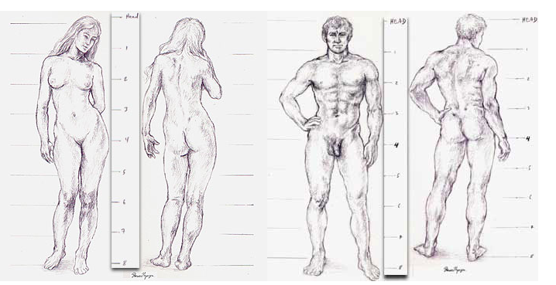
Assignment 2 Grading Criteria: | Maximum Points
Balance, scale and proportion, sketch and value, and overall unity of elements. | 4
Completeness of assignment - All elements listed above are included in the assignment. | 4
Clean, well crafted, and technically sound work. | 4
Actively participated in the discussion forum. | 4
Total: | 16
For assistance with any problems you may have when completing this assignment—OR—to offer your assistance to classmates, please use the Problems and Solutions Discussion area located through the left side navigation link.
Assignment 3: The 4-Part Figure and Gesture Drawing I
Complete the assignment by Thursday, July 17, 2008 and post it to the Discussion Area. Using a live model, create 10 stick figures and 10 stick figure/geometric shape drawings of different standing poses. You can put more than one figure on a page. All large parts of the body are to be represented by either line (stick figures) or geometric form (geometric shapes) (head, arms, legs, torso, feet, hands). This assignment must be completed by hand. Using the computer to complete this assignment will result in loss of points.
Use a digital camera or a scanner to digitize your drawings. Crop and or reduce the image size to 800 x 800 pixels (maximum) and 400x400 pixels (minimum) at 72 DPI. Please optimize your image so that it is no larger than 100k (50K +/- ideally) and save as a RGB, JPEG file.
Review and critique the work of at least two other students by the end of the week.
Example:
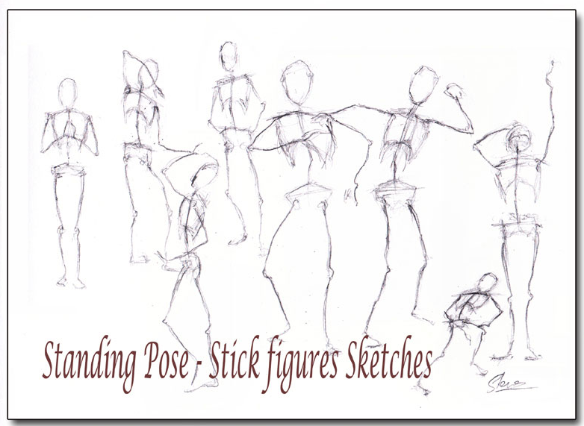

Assignment 3 Grading Criteria: | Maximum Points
Balance, scale and proportion, sketch and value, and overall unity of elements. | 4
Depiction of the center of gravity. | 4
Clean, well crafted, and technically sound work. | 4
Completion and accurate depiction of pose. | 4
Correct usage of geometric shapes. | 4
Actively participated in the discussion. | 4
Total: | 24
For assistance with any problems you may have when completing this assignment—OR—to offer your assistance to classmates, please use the Problems and Solutions Discussion area located through the left side navigation link.

Assignment 4: Upper Limb – Anatomy Drawing
By Saturday, July 19, 2008, draw one view of the skeletal system (from the Atlas of Human Anatomy for the Artist textbook) and one view of the muscle system (Peck 114-117) of the upper limb. This assignment must be completed by hand. Using the computer to complete this assignment will result in loss of points.
Submit your responses to the appropriate Discussion Area. Review and critique the work of at least two other students early in the week.
Think about presentation in terms of composition. You will be graded on accuracy and proportion of the forms as well as presentation.
Example:
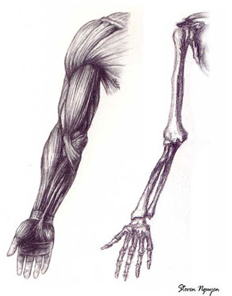
Be sure to resize and optimize your two images before posting.
Assignment 4 Grading Criteria: | Maximum Points
Balance, scale and proportion, sketch and value, and overall unity of elements. | 4
Clean, well crafted, and technically sound work. | 4
Completeness of assignment. | 4
Participation in discussion with class, feedback and comments. | 4
Total: | 16
For assistance with any problems you may have when completing this assignment—OR—to offer your assistance to classmates, please use the Problems and Solutions Discussion area located through the left side navigation link.

